**Arrested Developers**

**Speech Buddy: Mock-ups**

**William (N01046945), Sanjay (N01035282) and Kevin (N01051682)**

**Opening Screen (Displays App name, Logo and Developers)**

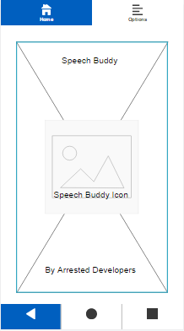

**Main Menu (Different Task lists, reminders and help)**

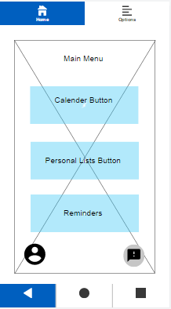

**Includes Profile button in bottom left, number of alerts and reminders upcoming in bottom right, as well as the main display for navigation**

**Note: Speech Buddy will be using androids already implemented calendar, and will open that application when selected.**

**Sample Personal List Display**

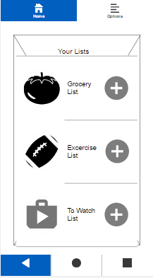

**Displays Users Created Lists for selection**

**List Elements (Within a List)**

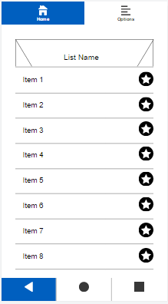

**Displays content of list created by user input from a database**

**Reminders List**

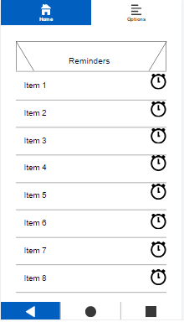

**Display reminders to user, as well as time remaining before deadline**